Return to Rock Climbing (Finger Pulley Injury)
- Resources
  - **How To Rehab a Climbing Finger Pulley Injury - The Climbing Doctor
  - Lutter, C., Tischer, T., & Schöffl, V. R. (2021). Olympic competition climbing: the beginning of a new era—a narrative review. British Journal of Sports Medicine, 55(15), 857-864.
  - Cooper, C., & LaStayo, P. (2019). A potential classification schema and management approach for individuals with A2 flexor pulley strain. Journal of hand therapy: official journal of the American Society of Hand Therapists.
  - Schneeberger, M., & Schweizer, A. (2016). Pulley ruptures in rock climbers: outcome of conservative treatment with the pulley-protection splint—a series of 47 cases. Wilderness & environmental medicine, 27(2), 211-218.
- Anatomy
  - 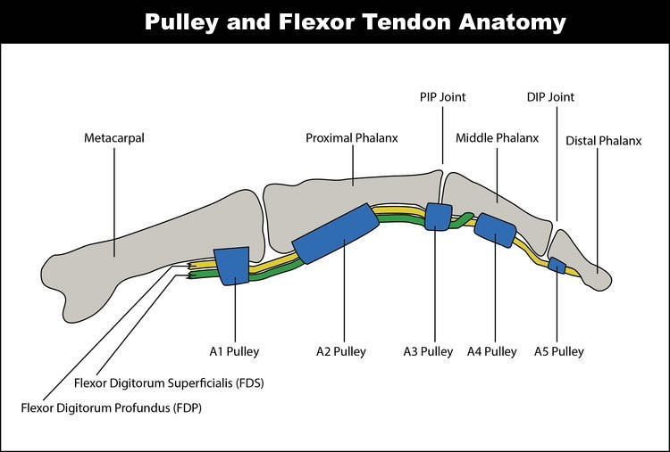
- Grading
  - Grades
    - I - stretch or slight tear
    - II - A3/A4 complete rupture, A2 partial tear
    - III - A2 complete rupture
    - IVa/IVb - Multiple complete ruptures
  - Diagnosis
    - US, CT, MRI (diagnostic US is gold standard)
    - Or clinical criteria (not correlated to grades in research, based on clinical experience)
 | Mild (I) | Moderate (II) | Severe (III)
Daily/Climbing Sx | 0/10 daily, doesn't limit activity  Climbing: < 2/10 after, only crimp grip is painful | 3-5/10 daily, doesn't limit activity  Climbing: > 5/10 that limits climbing in all grip positions | 5/10, limits activity  Climbing: > 5/10, severely limits climbing
ROM | Pain at end ROM finger flexion, no AROM loss | Pain at end ROM dinger flexion with < 25% AROM loss | Pain and >50% limited ROM with finger bending and straightening
RROM | Sloper: 0/10  Half crimp: < 2/10  Full Crimp: < 2/10 | Sloper: < 2/10  Half crimp: 2-5/10  Full Crimp: 6-8/10 | Pain and weakness with any finger flexor RROM testing or grip hand position
Palpation | Minimal pain with full blanching palpation (maximal pressure) | Pain with mild blanching palpation (moderate pressure) | Pain with no blanching palpation (minimal pressure)
- Importance?
  - Severity/grade determines how to best treat it
- Intervention
  - Timeline
 | Mild (I) | Moderate (II) | Severe (III)
No Pain Hanging Stage 1 | Wk 1-2 | Wk 2-4 | Wk 3-6
Easy Climbing | Wk 2-3 | Wk 4-6 | Wk 6-9
No Pain Hanging Stage 2 | Wk 2-3 | Wk 4-6 | Wk 6-9
Moderate Climbing | Wk 3-4 | Wk 6-9 | Wk 9-12
Low Pain Hanging Stage 1 | Wk 3-4 | Wk 6-9 | Wk 9-12
Hard Climbing | Wk 5-6 | Wk 9-12 | Wk 12-15
Low Pain Hanging Stage 2 | Wk 5-6 | Wk 9-12 | Wk 12-15
    - No Pain Hanging: hang-board with no pain
    - Low Pain Hanging: hang-board with 3/10 pain or less, doesn't linger more than 3 min
    - Easy Climbing: avoid half and full crimp, use large holds on faces not angled beyond vertical, 2 full grades below normal climbs (5.12 --> 5.10, V8 --> V6)
    - Moderate Climbing: start to use half crimp and mild angled holds beyond vertical, 1 full grade below normal climbs
    - Hard climbing: use crimps on routes with angle beyond vertical, can start to climb at normal level
- Immobilize
  - Improving bone tendon distance and allowing the pulley to fully heal is CRITICAL
  - H-Tape
- Best to reduce bone tendon distance and increases crimp grip; acts at A3 to unload A2 and A4
- 8 wks minimum. Wear daily and during exercise, replace as needed
- How
  - 1.5 inches athletic tape or Leukotape, tear each end halfway long ways to make an H, line middle of it up with A3 pulley (PIP) with finger in loose flexed position (60 deg angle), and tightly wrap around proximal and intermediate phalanges keeping finger at 60 deg flexion
  - Then take 2-3 inches athletic tape and figure 8 around the H tape
- Pulley protection splint
  - Orthotist, thermoplastic
  - BEST day to day to reduce bone tendon distance, wear for 8 weeks.
- Improve Mobility
  - Why
    - Circulation to healing structures
    - Adequate tendon gliding (FDP and FDS gliding underneath pulleys to help lubricate then and improve healing)
    - Maintain ROM
  - Finger tendon gliding
    - 2-3 x 15-20, daily symptom depending
    - 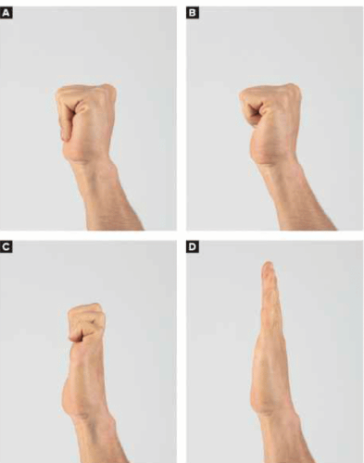
- Mobility Restoration
  - 2-3 x 15-20, daily, symptom depending
    - 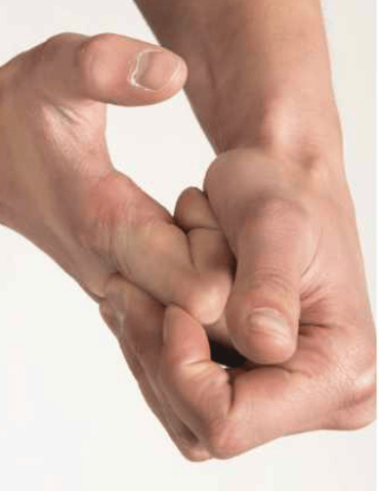
- Improve Muscle Strength
  - Key
    - Without irritating the pulley = progressive loading!!
  - What
    - Isometric grip with band or row machine/something similar --> concentric (working through ROM) grip with band/row machine
    - Hang board progression: keeping body on ground and gripping at progressive intensities (50% --> 75% --> 100%), can offload with band as well
    - Grip progression: open hand --> 1/2 crimp (90 deg angle with hand) --> 3 finger pockets --> 2 finger pockets
  - No pain protocols hang-board (repeaters; 3 min rest b/w sets)
    - Stage 1: 3 x 7 @ 7" on 3" off, 3x/wk, open handed
    - Stage 2: 3 x 7 @ 7" on 3" off, 3x/wk, open handed and half crimp
  - Low pain protocols hand-board (3 min rest b/w sets)
    - Stage 1: 1 x 4 @ 7" on 3" off, 2x/wk, open hand, half crimp, and 3 finger pockets
    - Stage 2: 1 x 4 @ 7" on 3" off, 2x/wk, open hand, half crimp, 3 finger pockets, 2 finger pockets
- Progressions
  - Time, speed, weight, isometric to concentric
  - Could do repeaters on Tindeq based on 1 RM grip strength of uninvolved hand (buy grip attachment; ask Aidan for his)
    - Test with Tindeq Duck Rings

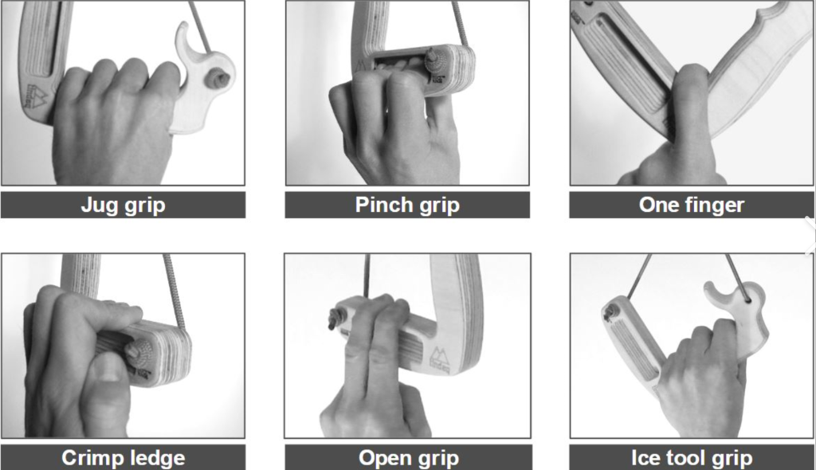
  - No Hang Finger Strength Testing for Climbers - The Climbing Doctor

Client Example

 | Moderate (II)
No Pain Hanging Stage 1 | Wk 1-4
Easy Climbing | Wk 4-6
No Pain Hanging Stage 2 | Wk 4-6
Moderate Climbing | Wk 6-9
Low Pain Hanging Stage 1 | Wk 6-9
Hard Climbing | Wk 9-12
Low Pain Hanging Stage 2 | Wk 9-12

- H Tape on while exercising/climbing
- Hang board progression: keeping body on ground and gripping at progressive intensities (50% --> 75% --> 100%), can offload with band as well
- Grip progression: open hand --> 1/2 crimp (90 deg angle with hand) --> 3 finger pockets --> 2 finger pockets
- No pain protocols hang-board (repeaters; 3 min rest b/w sets)
  - Stage 1: 3 x 7 @ 7" on 3" off, 3x/wk, open handed (easiest grip on hang board or pull up bar)
  - Stage 2: 3 x 7 @ 7" on 3" off, 3x/wk, open handed and half crimp
- Low pain protocols hand-board (3 min rest b/w sets)
  - Stage 1: 1 x 4 @ 7" on 3" off, 2x/wk, open hand, half crimp, and 3 finger pockets
  - Stage 2: 1 x 4 @ 7" on 3" off, 2x/wk, open hand, half crimp, 3 finger pockets, 2 finger pockets
    - Can start doing 1 finger pocket progressions at 12 wks

Definitions
- No Pain Hanging: hang-board with no pain
- Low Pain Hanging: hang-board with 3/10 pain or less, doesn't linger more than 3 min
- Easy Climbing: avoid half and full crimp, use large holds on faces not angled beyond vertical, 2 full grades below normal climbs (5.12 --> 5.10, V8 --> V6)
- Moderate Climbing: start to use half crimp and mild angled holds beyond vertical, 1 full grade below normal climbs
- Hard climbing: use crimps on routes with angle beyond vertical, can start to climb at normal level

- Where
  - L ring finger May/March 2023 - MILD
    - Near complete A2 rupture
  - R middle finger Feb/March 2024 - MODERATE
    - Problematic

