PROGRAM PLANNING HELPFUL INFORMATION

Rep Schemes Based on Training Phase (CSCS Textbook)
- Muscle Endurance: 2-3 sets x > 12 reps @ < 67% 1RM, < 30 sec rest
- Hypertrophy: 3-6 sets x 6-12 reps @ 67-85% 1RM, 30 sec-1.5 min rest
- Strength: 2-6 sets x < 6 reps @ > 85% 1 RM, 2-5 min rest
- Power (2-5 min rest)
  - Single effort event: 3-5 sets x 1-2 reps @ 80-90% 1 RM
  - Multi effort event: 3-5 sets x 3-5 reps @ 75-85% 1RM

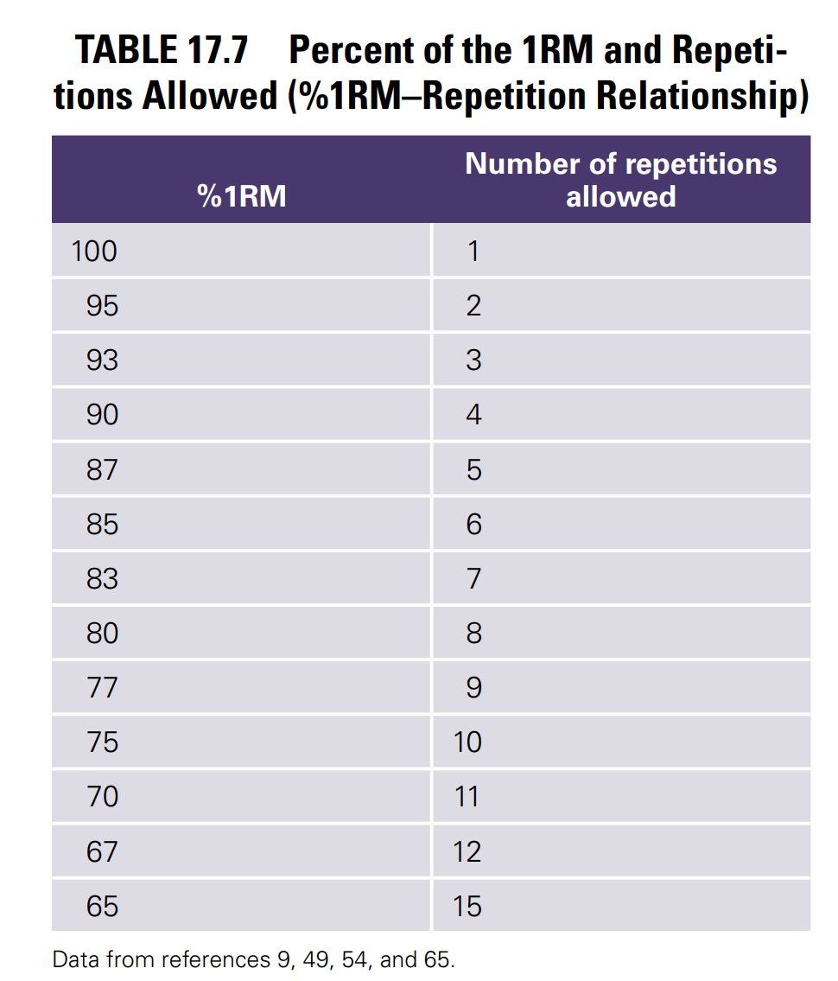

APRE (Autoregulatory Progressive Resistance Exercise)
- Objective way to progress exercise, particularly heavy compound lifts. Figure 2 helps determine how much weight to add to set 4 based on the number of reps completed in set 3.

PROGRESSIVE OVERLOAD!
- Ensure the patient is making progress and the load is sufficient!
- Don’t be afraid to increase the load and change exercises. The body needs new stimulus to adapt.

American Academy of Sports Medicine Weekly Exercise Guidelines (Determining HR Intensity):

- 150-300 min/wk of moderate intensity exercise (65-75% HRmax or 40-60% HRR or RPE 3-4 or steady conversation) or 75-150 min/wk of vigorous intensity exercise (76-96% HRmax or >60% HRR or RPE 5-7 or few words sustainable) plus 2 days/wk of resistance training.

Target Intensity
- Moderate: 40-60% HRR for 150 min/wk
- Vigorous: > 60% HRR for 75 min/wk
- Or combination of the two

Karvonen HR Reserve (HRR) Formula
- HR_{max} = 208 - (0.7 * age)
- HRR = HR_{max} - HR_{rest}
- Target HR = (HRR * intensity %) + HR_{rest}

Example
- Moderate intensity target HR range for 25 year old male with HR_{rest} of 45 bpm. HR_{max} = (208-[0.7*25]) = 190.5 bpm. HRR = 190.5-45 = 145.5 bpm. Target HR using 40-60% HRR guidelines: (145.5*0.4)+45 = 103.2. (145.5*0.6)+45 = 132.3 bpm. Moderate Intensity Target HR Range = 103-132 bpm.

Strength Training Phases (2-6 Weeks per Phase)

1. Connective Tissue Adaptation Phase
- Goal: Prepare connective tissues (muscle and tendons) for progressive loads. Does not significantly stress muscle fibers.
- Volume: 2 sets of 15-20 reps (<65% 1 RM)
- Rest: <30 seconds between sets

2. Hypertrophy Phase
- Goal: Stress muscle fibers to increase muscle cell size.
- Volume: 2-3 sets of 8-12 reps (65-80% 1 RM)
- Rest: 30-90 seconds between sets

3. Strength Phase
- Goal: Stress muscle fibers and enhance neurological stimulation; also includes power work.
- Volume: 3-5 sets of <8 reps (>80% 1 RM)
- Rest: 2-5 minutes between sets

Cardiorespiratory Program Considerations

Exercise Duration/Frequency Recommendations
- Moderate Intensity: 150-300 mins/week OR
- Vigorous Intensity: 75 mins/week

Target Heart Rate (HR) Ranges
- Moderate Intensity: 40-60% of HRR (3-4/10 exertion)
- Vigorous Intensity: 60-84% of HRR

