Tindeq Strength Testing Protocol
Intro:
- Download app (Tindeq Progressor) on your phone.
- Open the app and login, then hit the red button in the top right corner.
  - App login Information:
    - Username: info@fcapotential.org
    - Password: 123456
- Turn on the Tindeq by pressing the small black button, a light will flash.
- Click “scan” to connect to the Tindeq. Then calibrate the device by pressing “tare” when there is minimal to no tension through the device.
- The device will automatically power off 10 minutes after leaving the app.
Key Points:
- Perform testing at beginning of session after a low intensity warm up (3-5 min cardio or dynamic stretching). This helps to avoid fatigue and improve the accuracy of 1RM testing.
- Set up and verbal cues MUST be the same each time you assess 1RM strength. This ensures the greatest reliability and validity.
- CAUTION: you must record the max force produced with maintained form (not just the highest number on the Tindeq). Be sure to record the number just prior to losing form.
  - The Tindeq will continue to give a force output even after form is lost/compensatory strategies are used, so the maximum force produced on the Tindeq app may not be a true measure of strength.
  - Tip: have one person watch form and call out when it is lost and a second person record the force produced at that moment.

1RM Testing:
- Getting Started
  - Complete Intro Section.
  - In the app, select: “peak load” > “new session” > “right/left mode” > “start session” > assess max strength R vs L, be sure to toggle the side being tested to compare.
- Core
  - Tests:
- Rotation R/L (pulling out/away from frame)
- ES Standing Plank (pulling up)
- Abdominal Standing Plank (pulling down)
  - Setup: Athletic stance (slight bend in knees), arms fully extended, 90 degrees between trunk and arms, 90 degrees between the strap and extended arms, neutral spine and core braced, strap is taught and attached to frame (see pics).
  - Demo and instruct patient on proper form prior to testing
    - Stop test when form fails: pelvic rotation any direction, losing neutral spine, trunk lean any direction, elbows flex
  - Verbal cues: “on 3, gradually push out/up/down until maximal effort, without losing form… 1, 2, 3 – PUSH PUSH PUSH!”

.

- Great Toe Flexor Group
  - Set Up
    - Perform in supine with knee flexion and foot on carpet (see pictures).
    - Place a card attached to the Tindeq directly under the patient’s great toe.
    - Stabilize the patient’s ankle to minimize hamstring involvement.
  - Ensure the patient can perform great toe flexion without flexing at the MTP joint before testing.
  - Verbal cues: “on 3, push your big toe into the card as hard as you can while keeping your heel on the ground or moving your foot. Do not let me pull the card out from under you… 1, 2, 3 – PUSH PUSH PUSH!”
  - As the patient pushes their big toe into the ground, gradually pull the Tindeq out from under their toe.
    - Stop test if heel lifts, foot moves, or IP flexion is observed.

Additional Muscle Testing:
Quadriceps
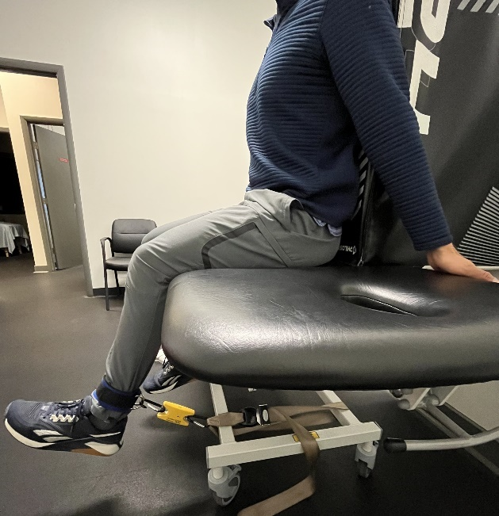
  - Set Up:

- 60 deg of knee flexion, 90 deg at hips, back rest, 90 deg b/w Tindeq device and shin, both hands gripping table (both behind or alternating).
- Ankle strap just proximal to malleoli.
- Verbal Cuing: “on 3, gradually kick out until maximal effort… 1, 2, 3 – KICK KICK KICK KICK!”
- Hamstrings
  - Set Up:

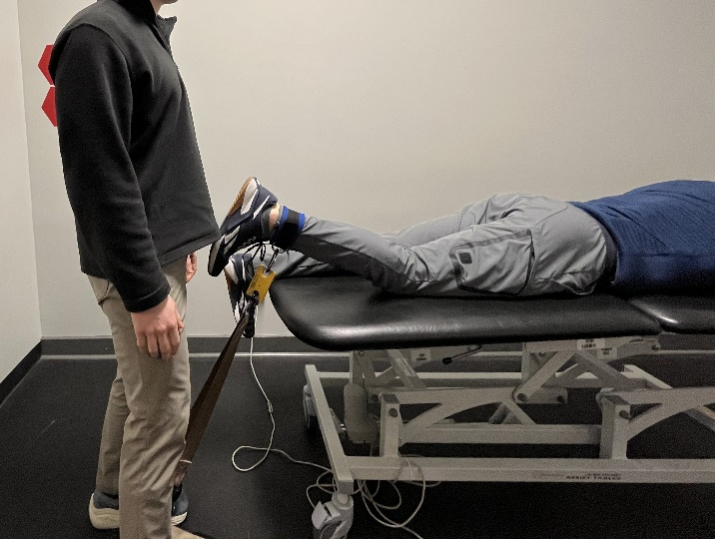
    - 15 deg knee flexion, patient grabbing table with both hands, can strap down hips if they ride off the table during testing.
    - Ankle strap just proximal to malleoli
    - Tester stepping on strap attached to the Tindeq with full BW over that foot for stability (tester may also need to grab the table)
    - Verbal cuing: “on 3, gradually kick in toward your butt until maximal effort… 1, 2, 3 – PULL PULL PULL PULL!”

(hand placement detail)
Using the Tindeq as an Intervention (Repeaters)
- Once connected, in the app select: “repeaters” à “new session” (or you can select a saved one) à “plot target levels” à Modify the sets/reps/work and rest time as desired, no gold standard here, just pick a reasonable start point and progress over time à input the “MVC” (maximal voluntary contraction = lbs of their 1 RM) then adjust the sliding bars to the % of MVC/1 RM you want to work at (rest often = 0% of MVC) à “start session”

