Week 1 Skills:
- Heart rate
- Blood pressure
- Lactate threshold
- Anthropometrics
- Orientation Guide

WEEK 1 SKILLS
1. Heart rate
- Find resting heart rate
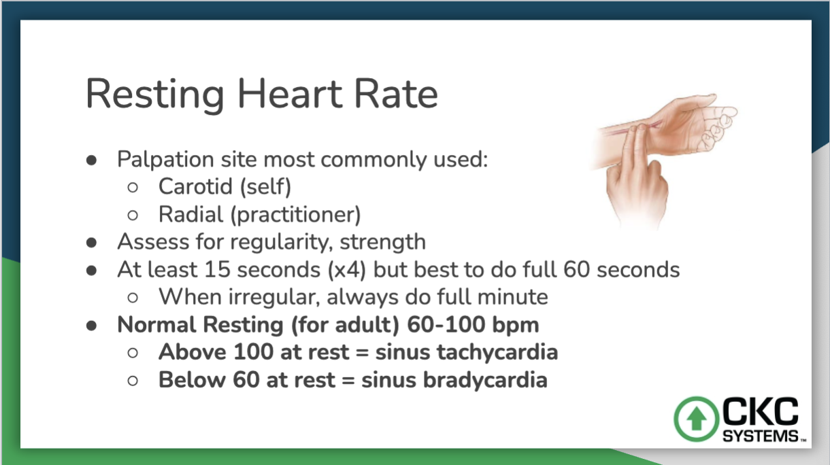
- Use Karvonen method to calculate target heart rate using RHR
Heart rate reserve (HRR) = (208 - 0.7(age)) - RHR
Target HR = (% HRR) + RHR
2. Blood pressure
- Practice taking blood pressure
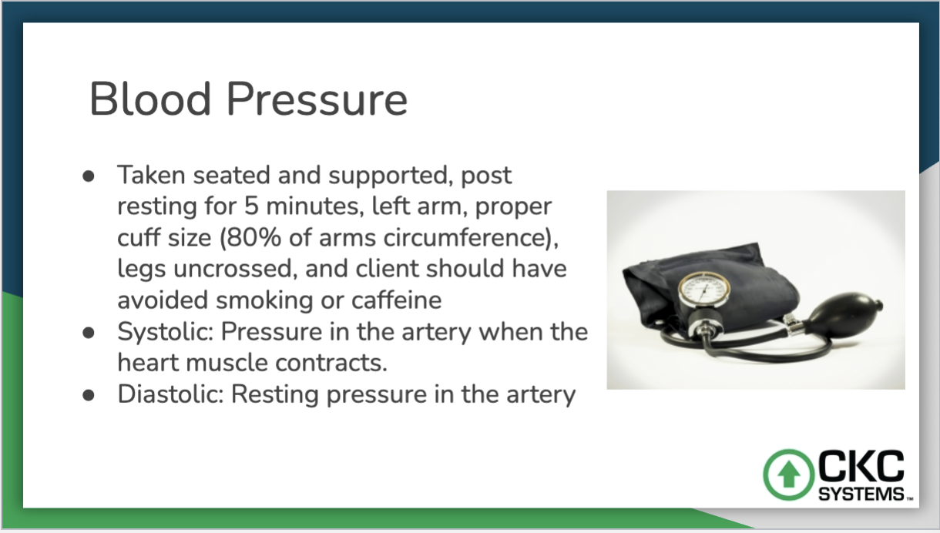
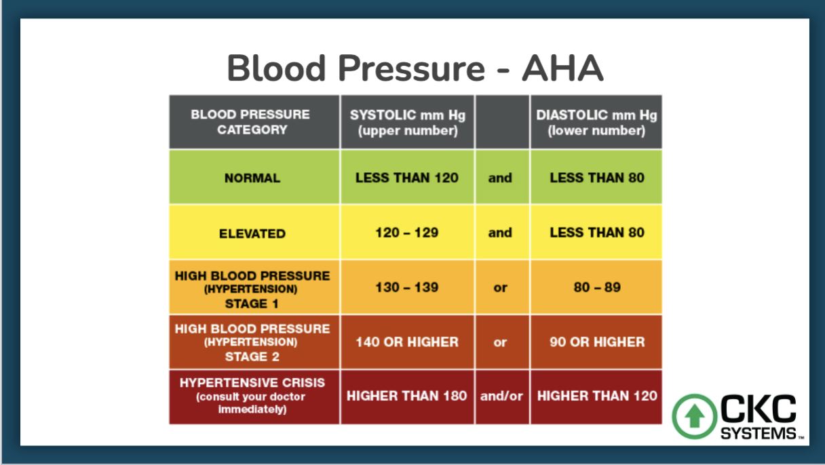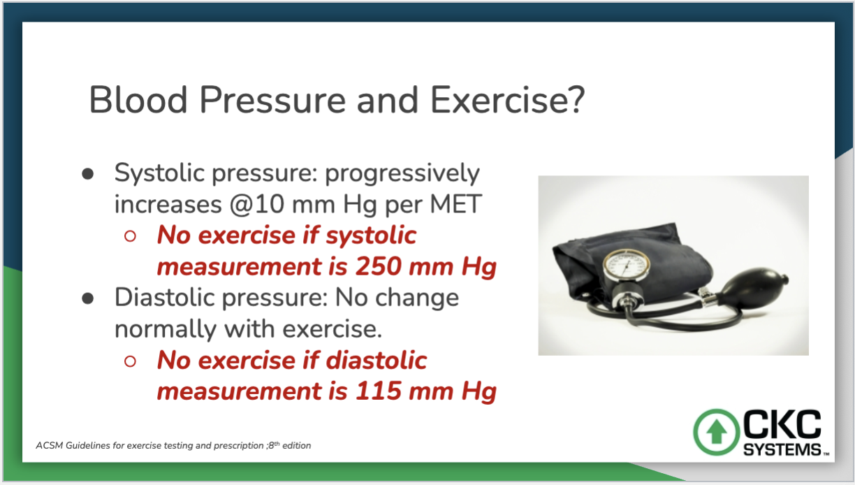

3. Anthropometrics
- Use the scale to take weight, find body fat percentage and lean mass
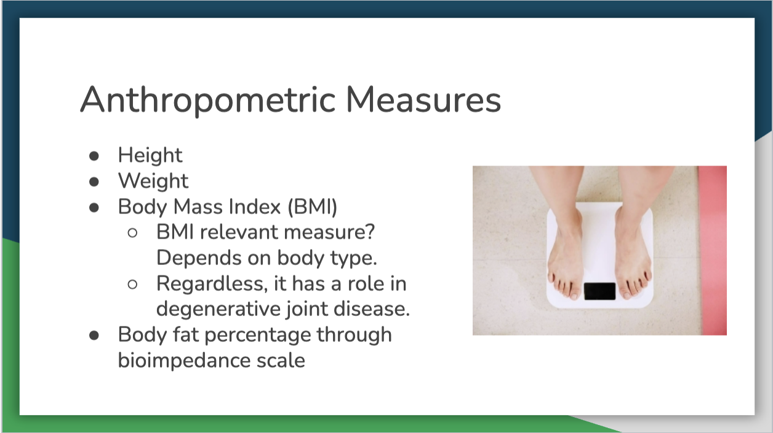
4. Lactate Threshold
- Teach another intern what lactate threshold is and why it matters when working with clients
o What is it
- Buildup of excess hydrogen ions
- Body is unable to clear lactate and hydrogen ions as rapidly as they are produced by working muscles at a given exercise intensity.
o Signs
- Pallor
- Nausea and dizziness
- Fatigue
- Heavy breathing
- Increased HR
- Excessive sweating
o What to do
- Have patient lie down with feet elevated above the heart
- Can provide cold compress
- Wait until HR and breathing return to normal before resuming exercise. May need to end session for the day.
o How to prevent
- Continually check in with patient—give opportunities for water and breathing breaks
- Gauge intensity of exercise correctly (pay careful attention when introducing exercise if client is deconditioned)
5. Orientation guide
- Read and sign orientation guide at either SHW or CROZET

