WEEK 3

Skills:
- Client specific functional scale: review and familiarize with a current intern
- Woodway treadmill: Practice and explain setting up with and without a harness with a buddy
- 10 RM Testing: Review and familiarize with a current intern
- Functional SL Testing: Practice evaluating SL stance with a buddy
- Thomas Test and hip flexor manual stretch: practice and explain with a buddy
- Hamstring flexibility test and stretch: practice and explain with a buddy
- High Volume Overspeed Training (HVOS): review sheet in clinic, familiarize w protocol, & the WHY behind (cont next week)
- Tendon toughening (TT): review & familiarize w common TT cases (RC, quad/patellar, post tib)

WEEK 2 SKILLS KEY (continuing into week 3)

- Muscle performance: strength
  - 10 RM testing
    - Review and familiarize with current intern (how to carry out testing, implications of under and overtraining)

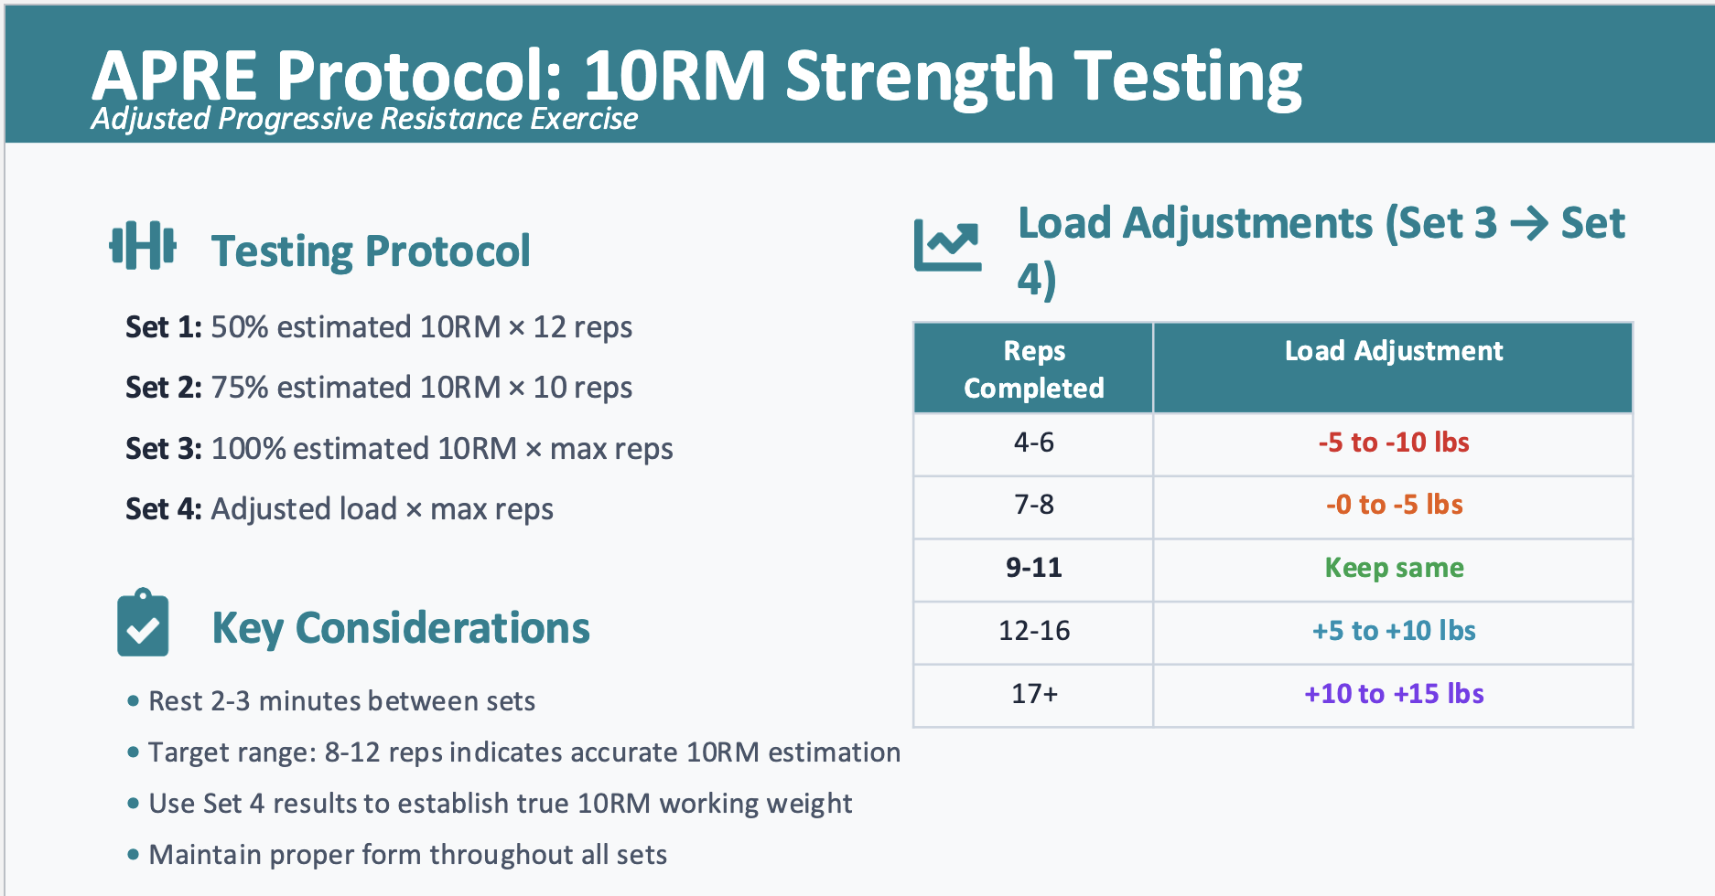

  - Functional assessment of SL movement
    - Be able to carry out SL stance assessment with current intern by having the client stand on each leg and evaluate COM shift, trunk lean, pronation/supination, etc.
    - Be able to fill out section of eval sheet
- Muscle performance: flexibility and stretches (hip flexor, hamstring, achilles)
  - Hip Flexor
    - Clinical skill
      - Implications for decreased flexibility (thomas stretch and HEP)
    - Thomas Test
      - Used to evaluate hip flexor ROM and flexibility
      - Have client lay on back and hug knees to chest, then drop leg so it hangs off the table
      - Measure the angle between the femur and the table to evaluate hip flexor tightness
    - Stretch
      - At home, clients can stretch hip flexors in a half kneeling or lunge position
      - Cue posterior pelvic tilt with a glute squeeze
  - Hamstring
    - Clinical skill
      - Implications for decreased flexibility/hamstring tightness (increased posterior pelvic tilt increases risk for disc bulges and flexion based injuries)
    - ROM
      - Stretch hamstrings when straight leg raise is less than 70 degrees
    - Stretch
      - Have client lay on back with proper lumbar support just above the pelvis (to prevent posterior pelvic tilt)
      - Manually push the leg in a straight leg raise (make sure knee stays locked)
  - Achilles
    - ROM
      - 10-15 degrees of ROM (10 is needed for normal gait)
      - To measure achilles ROM have client carry out knee-to-wall test
    - Stretch
      - Dorsiflexion stretch
      - Make sure to support medial arch when stretching posterior tissues
- Woodway treadmill
  - Practice setting up woodway treadmill offload with a buddy
  - Understand why we use offload (overspeed/gait training, reduce load on potential injuries, etc.)
- Client Specific Functional Scale
  - Review and familiarize with a current intern
  - Understand why and how the scale is used in clinic

WEEK 3 SKILLS KEY
7. High Volume Overspeed Training (HVOS)
- Purpose:
  - To improve neurological processing speed over time and maximize muscle hypertrophy
- Goal:
  - Get client move as fast as possible while maintaining form (exceptions w older clients)
  - Have client reach failure at 20th rep
- Protocol:
  - Find 20 rep max for key exercises. (Squat, upper body push/pull, core, SL movement)
  - Each exercise will begin with the 20 RM resistance/assistance. Every set should be slightly more offloaded than the last so that movement speed increases each time.
    - Despite offload, each round should be an adequate challenge as fatigue increases
    - Push client to move faster each round
  - Intern will time the client performing 20 reps of each exercise. Record both the offload and movement speed for every set.

8. Tendon Toughening (TT)
(overuse injury, overstretch injury, pain w contraction, strength discrepancy)

Background: tendons must be trained differently than muscles bc they’re…
- Avascular: less blood supply than muscle (heal slowly)
- Mostly collagen: less contractile tissue (respond diff to exercise)
→ collagen injuries often caused by overstretch/tension
→ TT loads tissue in shorted position to bring injured tissue closer tog
Principle: “time under tension” low load, prolonged duration, below pain tolerance
Volume: 2 sets 10–120” (hold isometric contraction- no length change/mvmt until fatigue/discomfort NOT pn)
- Discomfort: tired, heavy, achey, fatigued
Progression: Inc load once 2 x 120” holds are pain free
Rest: ~1-3 days
Pain threshold: <3/10, no worsening next day
Discharge: area consistently pain free + can hold 2 sets 60-120” at sufficient load
- Tendon adaptation, typically takes 8-12 weeks or longer

Rotator cuff muscles + actions:
S: supraspinatus – abduction
I: infraspinatus – external rotation
T: teres minor – external rotation
S: subscapularis – internal rotation

Scaption:
⇒ Primary muscles worked: Supraspinatus (abduction)
⇒ Set up:
- Dumbbells: hold dbs thumbs up btw 30-45 degree angle from midline body
- Band: step on one end of band and hold other end w arm in same position described above

Shoulder Resisted IR:
⇒ Primary muscles worked: Subscapularis
⇒ Set up: Anchor band at side frame hook. Hold band at hand maintaining 90 degree angle between upper and lower arm, with elbow tucked in. You’re pulling IN as the band tries to pull you out.

Shoulder Resisted ER:
⇒ Primary muscles worked: Infraspinatus & teres minor
⇒ Set up: Anchor band at side frame hook. Hold band at hand maintaining 90 degree angle between upper and lower arm, with elbow tucked in. You’re pulling OUT as the band tries to pull you in.

Post tib TT: Inversion + plantarflexion

Quad/Patellar tendon: Knee extension hold, Spanish squat hold

