WEEK 7

Skills:
- Walking analysis: foot position (ER vs IR as a clue to femoral torsion)
- Structural exam (pelvis height, rotation, ES mass, acromion, SL stability) to create a full picture and clinical understanding
- Craig’s test: femoral anteversion/retroversion assessment
- FADIR, FABER

WEEK 7 Skills
- Walking analysis: foot position (ER vs IR as a clue to femoral torsion)
  - How to perform
    - Have client walk down and back across the room
    - Determine if the client internally or externally rotates at the foot throughout their gait
  - Interpretation
    - External rotation at the foot
      - Could reflect retroversion (structural)
      - Could reflect a leg length discrepancy (longer leg externally rotates to functionally shorten that side and even out the pelvic table)
    - Internal rotation at the foot
      - Could reflect excessive anteversion (structural)
      - Could reflect a leg length discrepancy (shorter leg internally rotates to functionally lengthen that side)
- Structural exam (pelvis height, rotation, ES mass, acromion, SL stability) to create a full picture and clinical understanding
  - Structure
    - Pelvic table
      - Have client stand in front of you with shoes/socks off, feet together, knees extended
      - Place both hands on top of the iliac crest
      - Determine if there is a leg length discrepancy based on the position of the hands atop the iliac crest
    - Rotation
      - While blocking the pelvis to prevent hip rotation, instruct the client to rotate as far as they can to one side
      - Perform on both sides and determine which side showed greater rotation ROM
    - Erector spinae
      - Have client hinge at the hips and reach towards their toes while keeping knees straight
      - View the erector spinae on each side and feel the difference in muscle mass on each side
    - Acromion height
      - Determine which shoulder rests higher when the client stands feet together with knees fully extended
      - When the pelvic table height is known, acromion height helps to complete the picture of the structure of the spine: C curve vs S curve vs shift
  - Function
    - SL stability (SL squat test)
      - Have client perform a SL quarter squat and record any movement faults that occur
      - Possible movement faults: loss of great toe contact with the ground, pronation, dynamic knee valgus, ipsilateral trunk lean, contralateral pelvic drop, loss of balance, etc.
  - Application
    - Knowing whether there is a leg length discrepancy can help to tease out whether external/internal rotation during gait is the result of structure or a functional compensation
    - Example: client externally rotates on the R side when walking. If Craig’s test shows normal normal anteversion but a structural exam shows R side high, it is more likely that the external rotation serves to functionally shorten the taller side
- Craig’s test: femoral anteversion/retroversion assessment
  - How to perform
    - Have client lie prone on the table and flex one knee
    - Palpate the greater trochanter on the side of the hip
    - By moving the leg into external and internal rotation, determine the position at which the greater trochanter is most prominent
  - Interpretation of results
    - Normal degree of anteversion = 10-20 degrees
      - Results are interpreted relative to the normal degree of anteversion!
      - A vertical tibia is retroverted compared to the normal degree of anteversion!
    - Excessive anteversion = greater than 20 degrees of anteversion
      - Lower leg will be rotated further from midline than normal
    - Retroversion = less than 10 degrees of anteversion
      - Lower leg will be rotated closer to the midline than normal
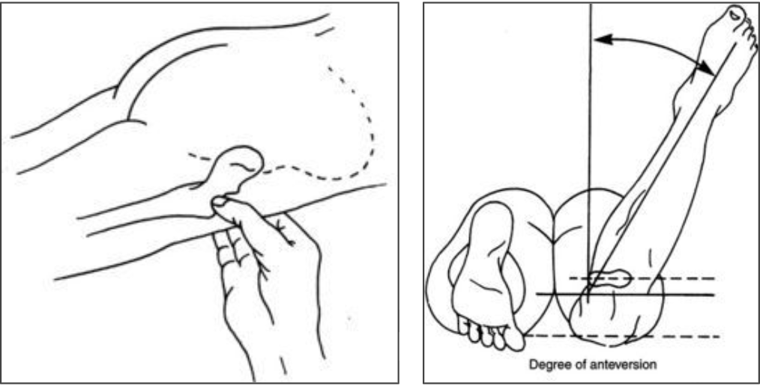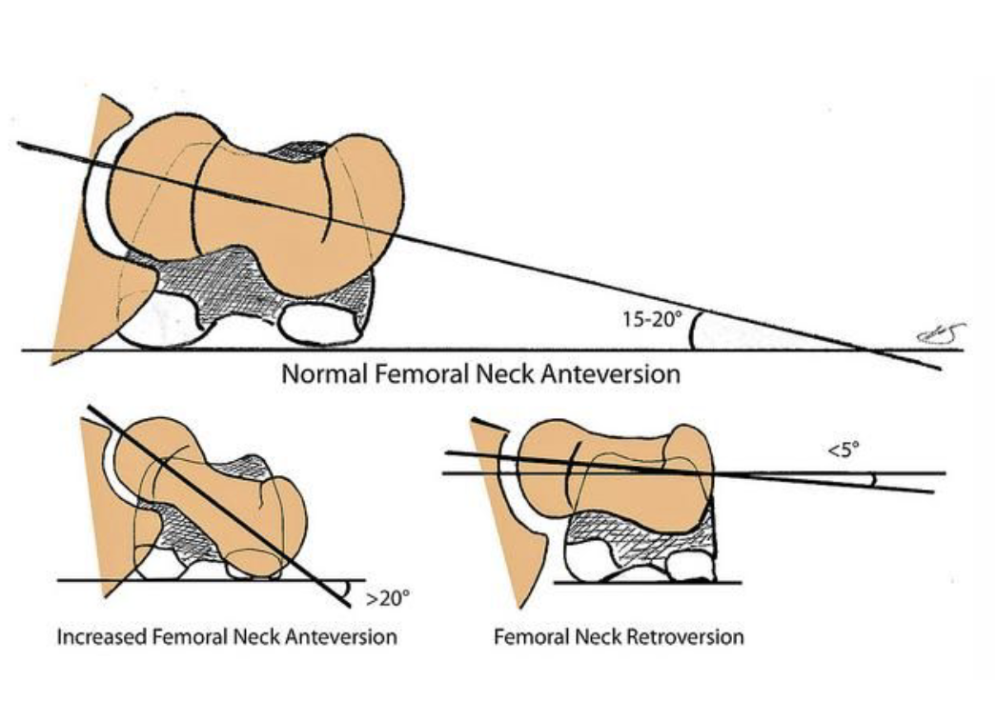

- FADIR, FABER
  - What are they?
    - Two tests that can be used to diagnose femoral acetabulum impingement (FAI)
    - Both can be positive in the case hip impingement
  - FADIR = flexion, ADduction, internal rotation
    - Have client lie supine and bring them into hip flexion, adduction, and internal rotation
    - This position maximally closes the hip joint space and will likely be the most aggravating in the case of impingement
  - FABER = flexion, ABduction, external rotation
    - Have client lie supine and bring them into hip flexion, abduction, and external rotation
    - This position can also be aggravating in cases of impingement, but not always (depends on the location of impingement)
- CAM vs Pincer hip impingement (nice to know, but not on skills list!)
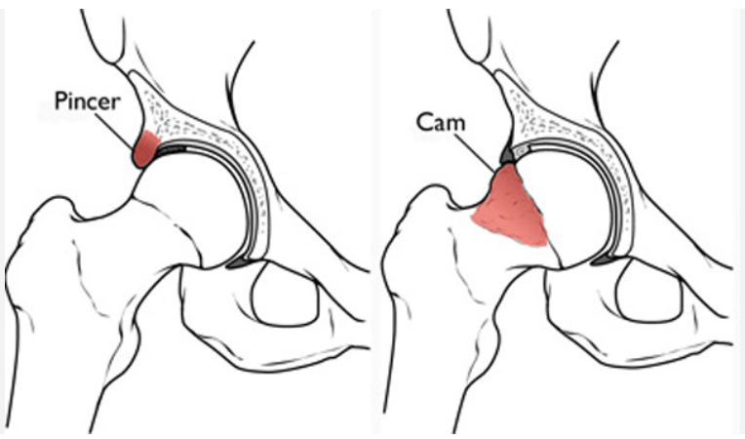
  - CAM impingement
    - Bony growth on the femoral head
    - Decreases hip joint space
  - Pincer hip impingement
    - Bony growth on the acetabulum
    - Decreases hip joint space
  - Really only differentiated by imaging

